**Alaska Children’s Alliance**

**P.O. Box 672069**

**Chugiak, AK 99567**

**907-688-0163**

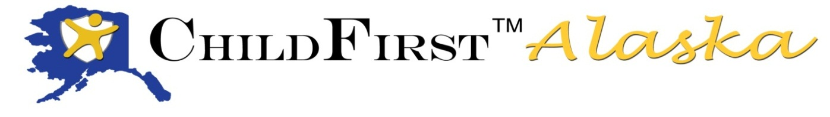

**30 more receive ChildFirst Alaska training**

May 2014 saw the graduation of our 4th group of ChildFirst Alaska Forensic interviewers. This was the first class taught entirely by our newly approved Alaska faculty, as well as the first class training on the updated protocol. The Gunderson National Child Protection Training Centerand thestate coordinators routinely review current research, case law and best practices to update the protocol as necessary in order to provide the very best forensic interviews to children who may have been victims of child abuse or who are witnesses to crimes.

*ChildFirst Alaska* is a joint effort by the Alaska Children’s Alliance, the Department of Public Safety, the Department of Law, Office of Children’s Services, UAA Child Welfare Academy and Child Advocacy Center staff and Multidisciplinary Team members.

Seventeen law enforcement from twelve communities, nine Office of Children’s Services staff serving seven communities, one assistant district attorney and three Child Advocacy Center staff from two areas were certified in this nationally recognized, best-practice model during this session.

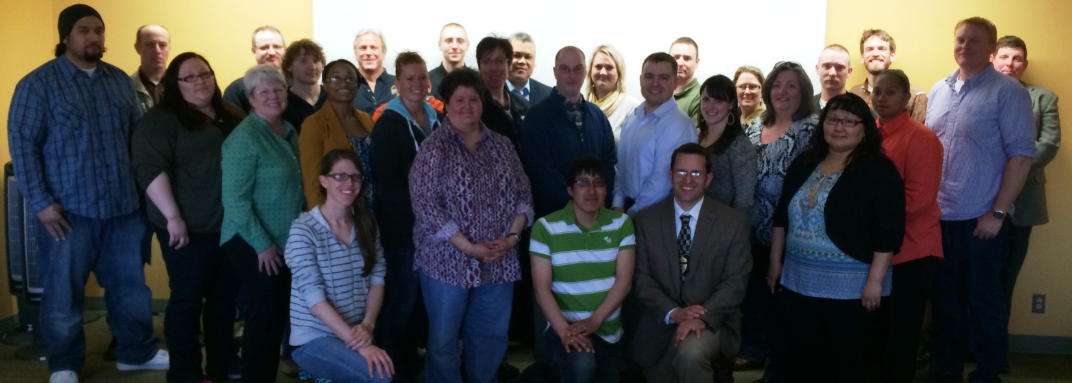

The training ended on a somber note with the news that two Alaska State Troopers, Sgt. Scott Johnson and Gabe Rich, lost their lives in the line of duty. Many of us knew one or both of these men.

The faculty and class members took time before the ChildFirst final exam to honor the fallen as they were transported to the Medical Examiner’s Office.

Our hearts go out to the families, friends and colleagues of Troopers Johnson & Rich

