**Alaska Children’s Alliance**

**P.O. Box 672069**

**Chugiak, AK 99567**

**907-688-0163**

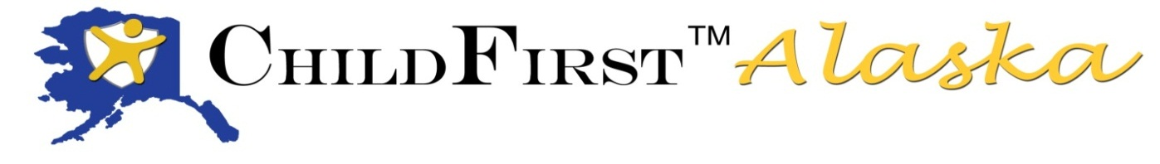

**Another ChildFirst Alaska class graduates!**

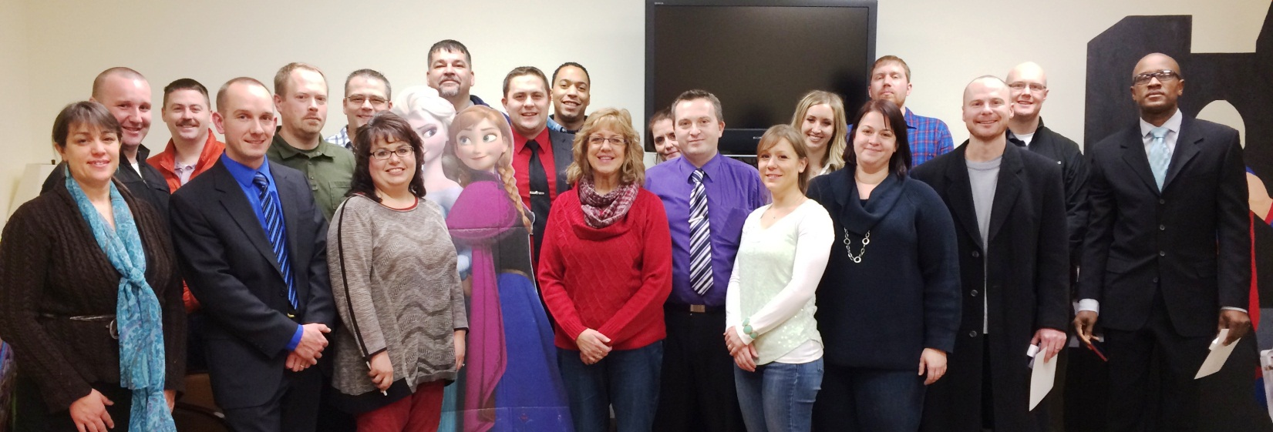

The collaborative and on-going effort to improve the system response to children who are suspected victims of child abuse or witnesses to crimes saw another class of successful child forensic interviewing graduates. Those graduates included 11 law enforcement, 5 OCS staff, 1 Child Advocacy Center staff, 4 Assistant District Attorneys and 1 Assistant Attorney General. They serve across the state, from Barrow to Bethel to Juneau and places in between. This class was held in Fairbanks, the first time outside of Anchorage. Thanks to RCPC Stevie’s Place CAC Manager Lori Markkanen for helping to make this happen. We learned a lot!

*ChildFirst Alaska* is a joint effort by the Alaska Children’s Alliance, the Department of Public Safety, the Department of Law, Office of Children’s Services, UAA Child Welfare Academy and Child Advocacy Center staff and Multidisciplinary Team members.

This nationally recognized, best-practice model is an intensive 5-day course, with a full day in class followed by homework in the evening. In order to receive certification, attendees must successful complete a practice interview applying the ChildFirst© protocol and pass a written essay exam at the end of the course. Thanks to instructors Deven Cunningham, Brittany Dunlop, Lori Markkanen and Tisha Simmons for making this class a success!

These dedicated actors are key to the success of the training. Ever committed to doing the best job possible, they decided to conduct a peer review of their roles from a previous training. Here, at the end of a long day, (from L to R) Vivian Melde, Tiffany Hall, Nava Sarracino Tony Vita and Kelly Wilson squish together in a hotel room to review practice interviews and give feedback to each other.

