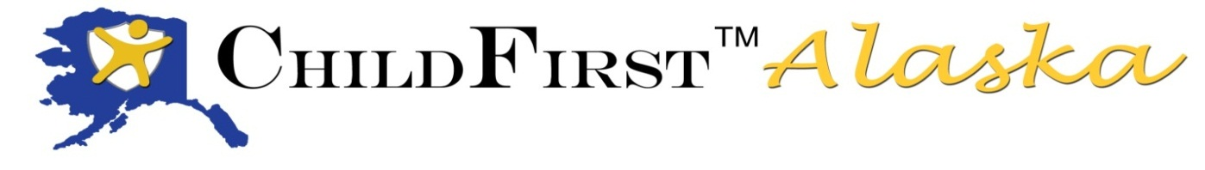
Alaska Children’s Alliance
P.O. Box 672069
Chugiak, AK 99567
907-688-0163

February 2015 ChildFirst Alaska graduates!

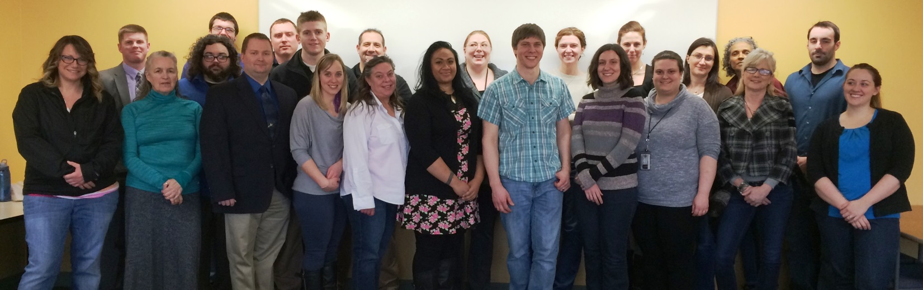

In a state with one of the highest rates of child abuse in the nation, providing effective forensic interviews to children who are suspected victims of child abuse or witnesses to crimes is critical both for the long-term safety of that child, but also of children who are likely to be victimized in the future. We are proud to congratulate another class of successful child forensic interviewing graduates. Those included 5 law enforcement, 14 Office of Children’s Services staff, 1 mental health provider, 1 Assistant District Attorney and 1 Assistant Attorney General. They serve across the state, including Anchor Point, Anchorage, Bethel, Fairbanks, Juneau, Kenai, McGrath, Soldotna, Valdez and Wasilla.

This nationally recognized, best-practice model is an intensive 5-day course that has been adopted by 19 states as well as Columbia and Japan. Thanks to instructors Johana McMahan, Milton Bohac, Brittany Dunlop, Pam Karalunas and Deven Cunningham who provided the February 2015 training and for their ongoing commitment to improving the child forensics interview skills of their peers and colleagues throughout Alaska!

ChildFirst Alaska is a collaborative effort by the Alaska Children’s Alliance, the Department of Public Safety, the Department of Law, Office of Children’s Services, UAA Child Welfare Academy and Child Advocacy Center staff and Multidisciplinary Team members.

Quyana to our behind-the-scene members of the ChildFirst Alaska Leadership Team:
- Kim Guay, Leadership Team Chair, Child Welfare Administrator, OCS
- Brittany Dunlop, Assistant District Attorney, Criminal Division, Palmer
- Carla Erickson, Chief Assistant Attorney General, Child Protection Division
- Cindi Stanton, Sargent, Crimes Against Children Unit, Anchorage Police Department
- Cory Bryant, University of Alaska Child Welfare Academy trainer
- Jennifer Maier, Social Services Program Officer, OCS
- Jessica Lawmaster, Executive Director Haven House, Homer
- Pam Karalunas, Chapter Coordinator, Alaska Children’s Alliance
- Randi Braeger, Domestic Violence & Sexual Assault Coordinator, Dept. of Public Safety
- Richard Bloomquist, Social Services Program Coordinator, OCS

