Alaska Children’s Alliance
P.O. Box 672069
Chugiak, AK 99567
907-688-0163
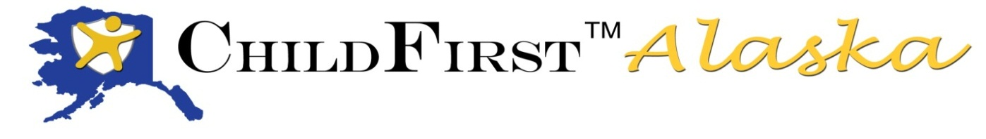

5th ChildFirst Alaska training completed!

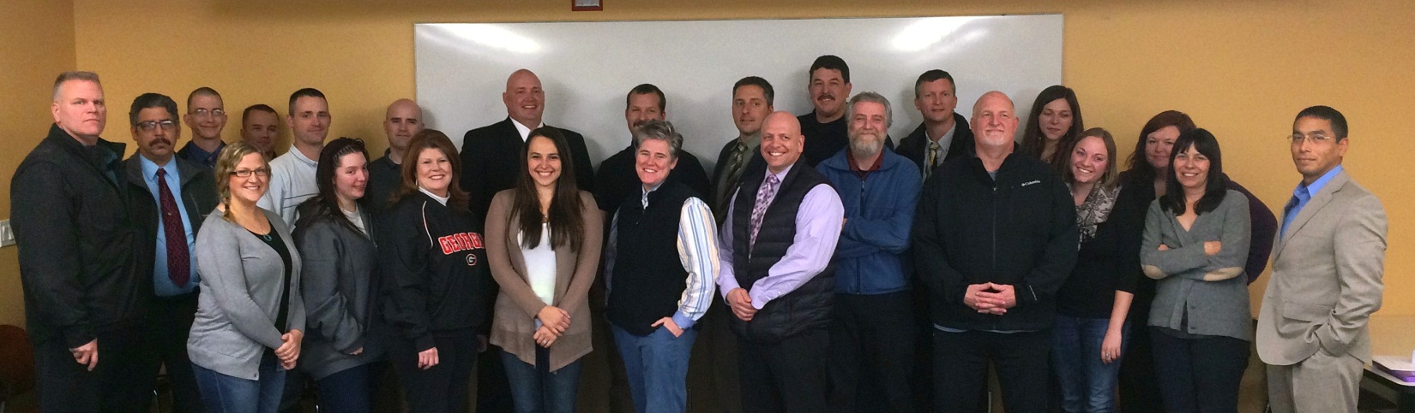

The collaborative and on-going effort to improve the system response to children who are suspected to be victims of child abuse or witnesses to crimes saw another class of successful child forensic interviewing graduates. Those graduates included 12 law enforcement serving seven communities; 10 OCS staff serving seven communities and 3 Child Advocacy Center staff from three communities.

ChildFirst Alaska is a joint effort by the Alaska Children’s Alliance, the Department of Public Safety, the Department of Law, Office of Children’s Services, UAA Child Welfare Academy and Child Advocacy Center staff and Multidisciplinary Team members.

This nationally recognized, best-practice model is an intensive 5-day course, with a full day in class followed by homework in the evening. In order to receive certification, attendees must successful complete a practice interview applying the ChildFirst© protocol and pass a written essay exam at the end of the course. Thanks to instructors Deven Cunningham, Brittany Dunlop, Jessica Lawmaster, Johana McMahan, Ginny Moring and Tisha Simmons, along with actors Tiffany Hall, Vivian Melde, Nava Sarracino, Tony Vita and Kelly Wilson for your part in making this class successful!

HARD AT WORK TAKING THE EXAM
